|  |  |
| --- | --- |
| Name: | Uwe |
| Age: | 33 |
| Highest Degree: | Ausbildung |

**Questionnaire**

Background Information:

* Figure shows patterns of movements to several locations of a user.
* The different locations are indicated as numbers (1, 2, 3..) on every hour basis.
* Example: On 20th day, between 5 am and 6 am, user is at location 14.
* The pattern can indicate some semantic meanings behind the location id numbers. For example: 6 can be regarded as “home” and 7 can be regarded as “work”
* You should focus on patterns like what are user’s working hours

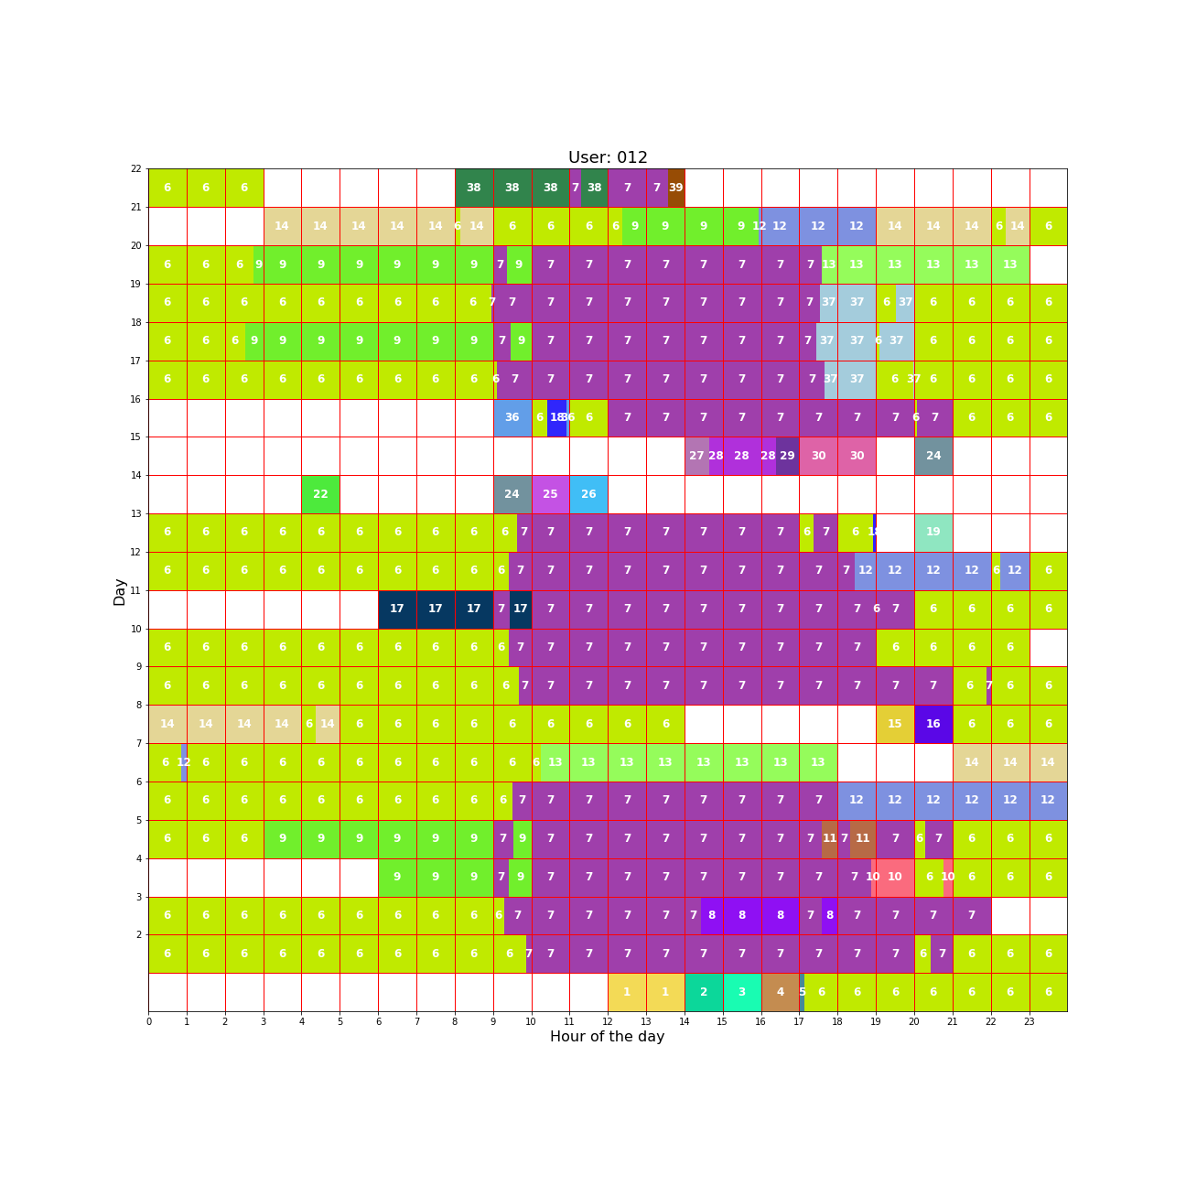Question: How long will the user stay at location 7(Work) if he was observed at location 7(Work) at 9 am.

Hour

Answer: 20 Uhr